THE UGANDA INTERGOVERNMENTAL FISCAL TRANSFERS (UGIFT)

FIELD ASSET VERIFICATION REPORT OF
LAMWO HEATH CENTER AND SCHOOLS

Date: 28th / 08/ 2026
LAMWO LOCAL GOVERNMENT
CAO:
- Opira Emmanuel welcomed us and introduced us to the DEO and the DHO.
- They helped us to inform the local people of the facilities
- The district did not have the specific UGIFT Asset Register.

FACILITY ONE: NGOROMOROMO HC III, LOKUNG SUB-COUNTY, LAMWO DISTRICT
Narratives from the focal person in charge Mr. Opira Emmanuel.
- NGOROMOROMO HC III have not benefited from UGIFT Programme.
- The facility has never received any UGIFT asset or buildings.
- There was no any building facility or any UGIFT Asset from UGIFT Programme
The information from the office of the District Health Officer at Lamwo District Headquarters, the council of the district agreed to shift all UGIFT Assets and building facilities meant for Ngoromorom HC III to Pangira HC II, Pangira Parish, Ogom Sub-County in Lamwo District.

FINDINGS AT PANGIRA HC II, PANGIRA PARISH, PANGIRA SUB-COUNTY IN LAMWO DISTRICT
- Maternity Ward building
- 1 building for the staff
- Water tanks (Not in Use)
- 1 toilet
The above assets are only what Pangira HC II in Pangira Parish benefited from UGIFT Programme.
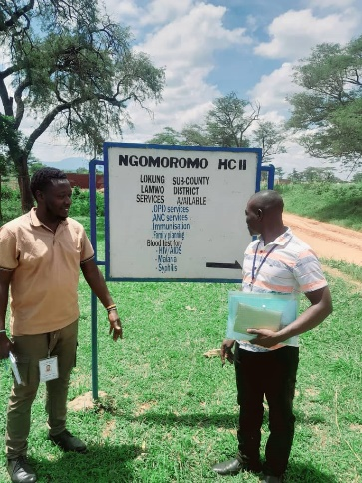
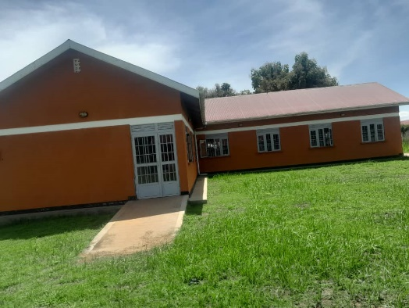
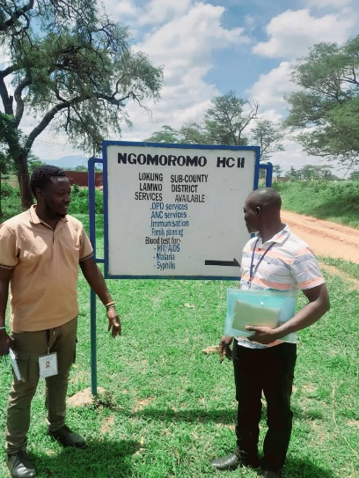
IMAGES FROM HC II

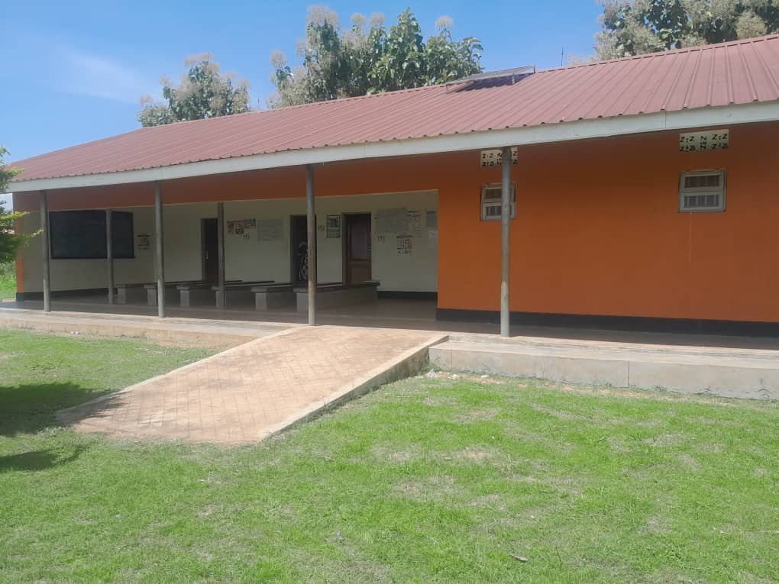
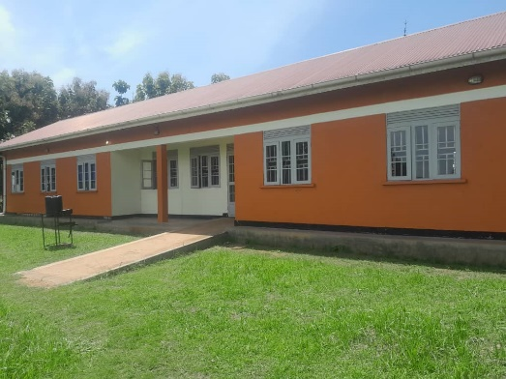
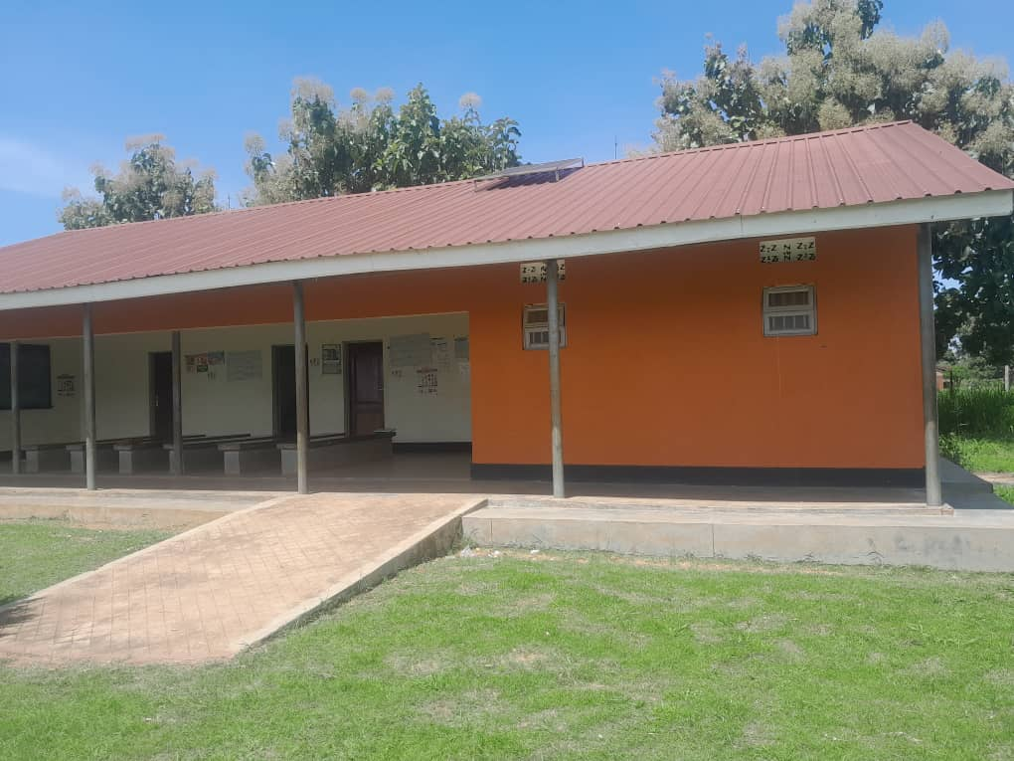

KATUM HEALTH CENTER, KATUM SUB – COUNTY, LAMWO DISTRICT.
Information from the focal person (incharge) Janet Amiito. She welcomed us warmly and took us through what the Katum HC III benefited from UGIFT Programme.

FINDINGS.
- 1 maternity ward building
- 1 toilet
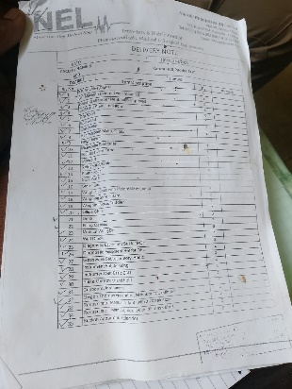
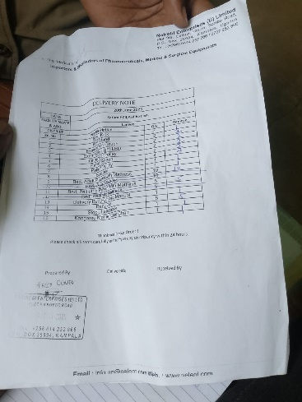
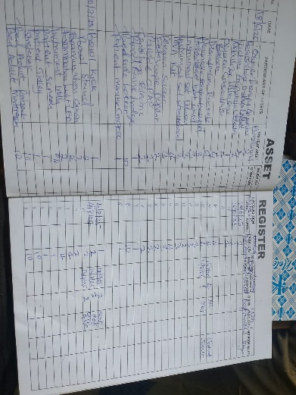
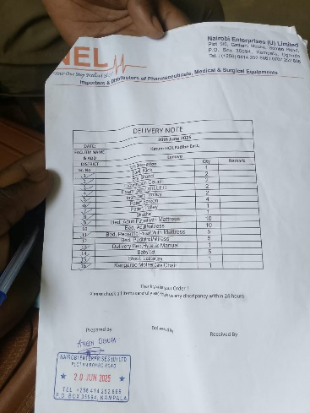
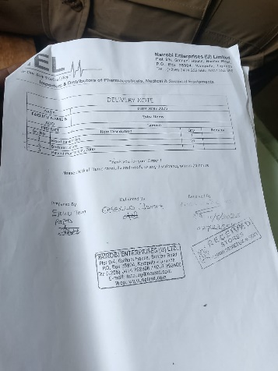
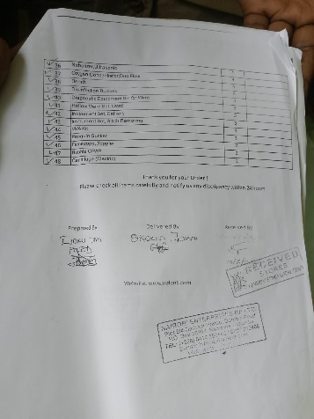
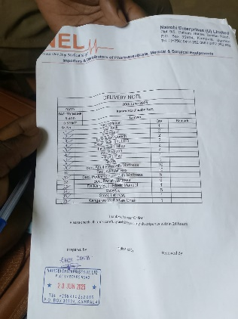
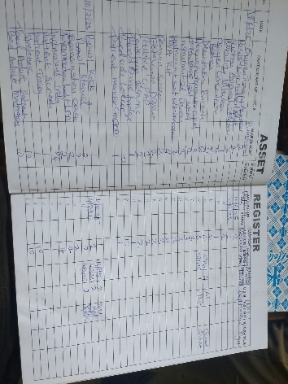
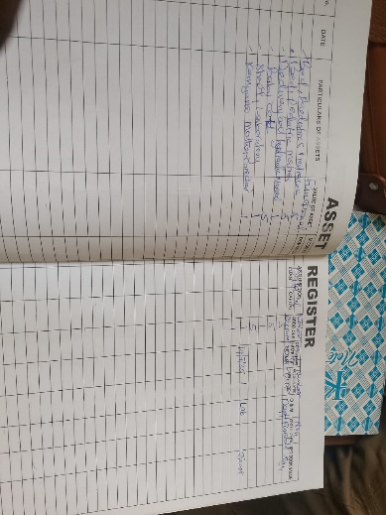
- And all the required medical assets as listed in the attached facility register below and some of the photos taken.

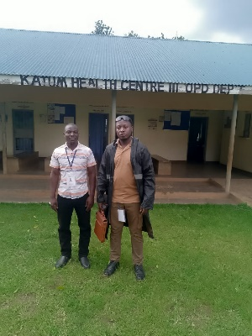

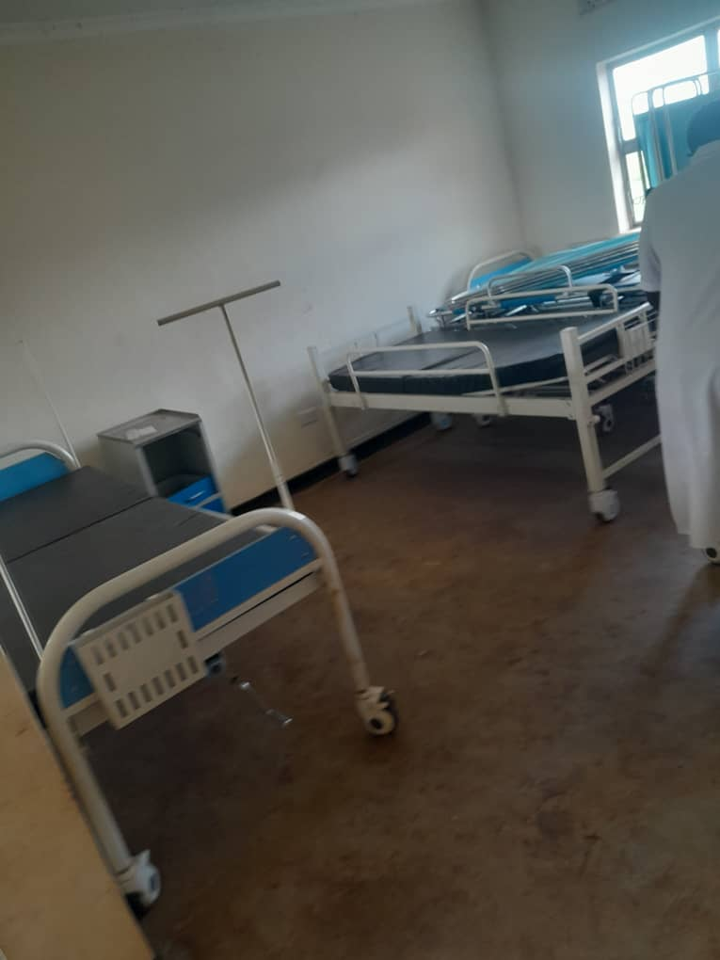
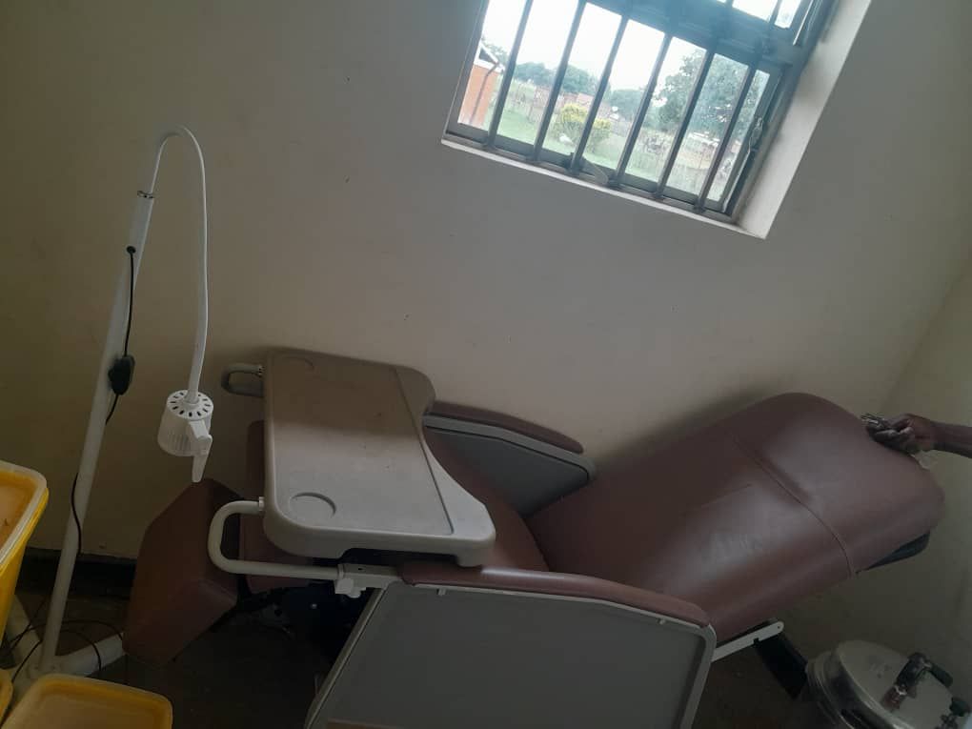
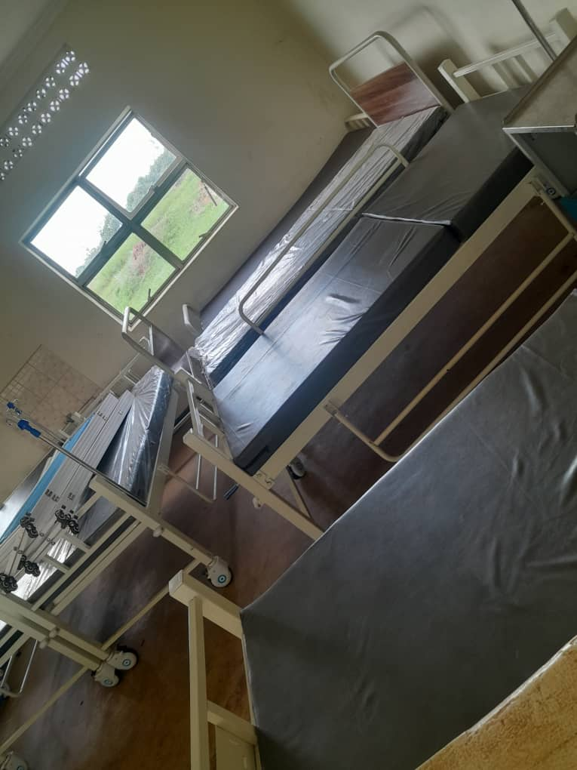
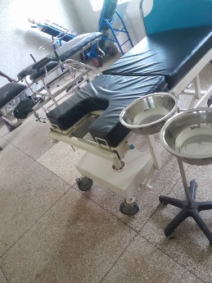
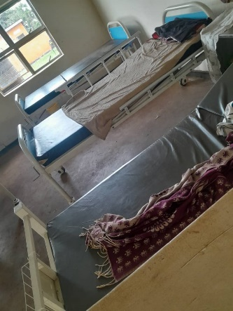
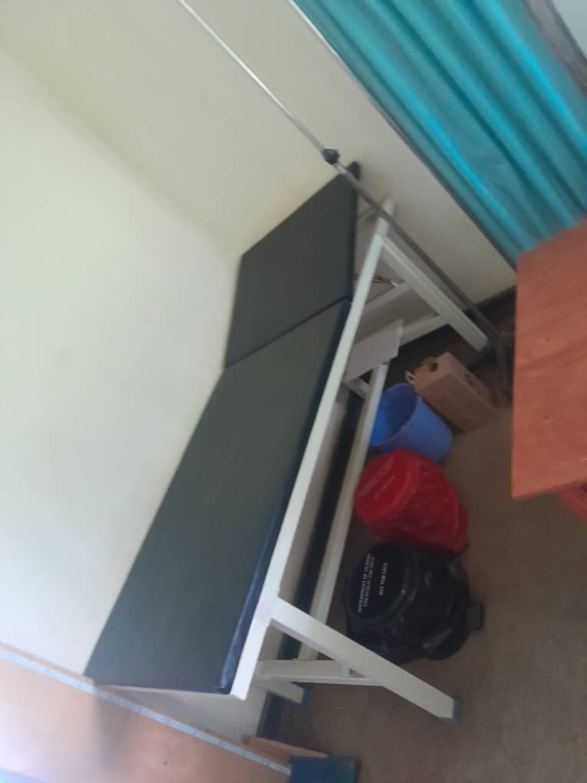
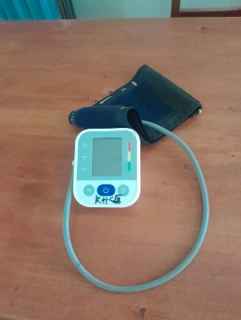
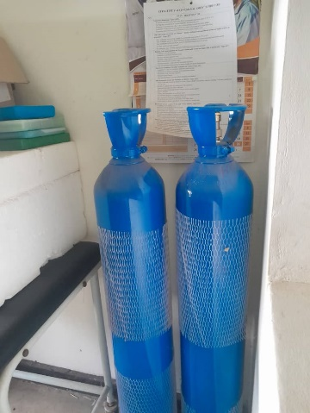
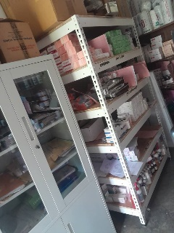
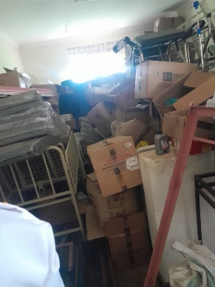
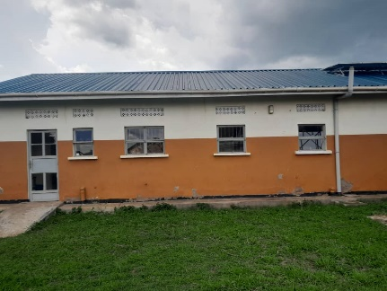
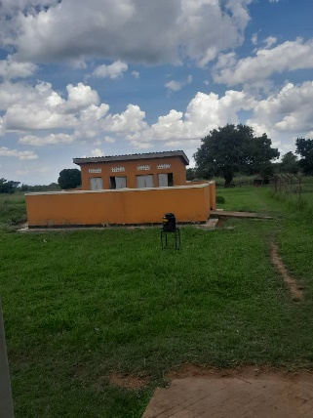
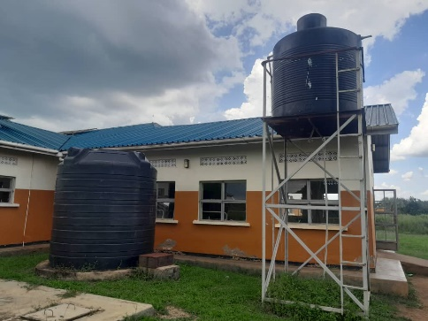

CHALLENGES
- Few Medical personnel
- Unreliable power Supply
- Few staff quarter.

RECOMMENDATIONS
- Employ more medical personnel’s
- Provide reliable power supply
- Build more staff quarters.

PALOGA SEED SECONDARY SCHOOL, PALOG SUB – COUNTY, LAMWO DISTRICT
Information from focal person (HD) Mr. Odyeny Tom Richard. He warmly welcomed us and he took us through the assets and facilities the school benefited from UGIFT Programme.

FINDINGS
SCHOOL BUILDINGS
- 6 class rooms
- 1 laboratory block with two science laboratories
- 1 multi-purpose hall equivalent to 3 classes
- 1 block for Library and Computer laboratory
- 6 staff house units and 6 staff kitchen units
- 2 toilets at Staff Quarters each with 2 standers
- 1 staff school toilet with 2 standers
- 2 school toilets for both boys’ and girls’ students each with 5 standers
- 1 Big Gas cylinder
- A school pitch
- A fence with wire mesh
FURNITURE
- 120 Desks, 20 Per Class
- 90 Tables
- 6 Wardrobes each per class
- 40 Stool for Laboratories
- 12 Office Chairs
ICT DEPARTMENT
- 18 Desktop Computers (DELL) and 2 were stolen
- 1 Air conditioner with all Components
- 1 camera with all components
- 1 server with all components
- 20 UPS with all Components
- 2 D-Link and 2 Wireless Routers
- 1 Network Switch
NB: the verifiers were not able to access the computer laboratory because the focal person at the facility had no key to open but the verifiers used the computer lab windows to take some of the photos.
CHALLENGES
- No reliable power supply
- No reliable water supply
- Insecurity
- Class room repair
- Classroom furniture repair
RECOMMENDATIONS
- Provision of reliable water source
- Provision of power supply
- Provide security
- Repair the worn out class rooms
- Repair class room furniture

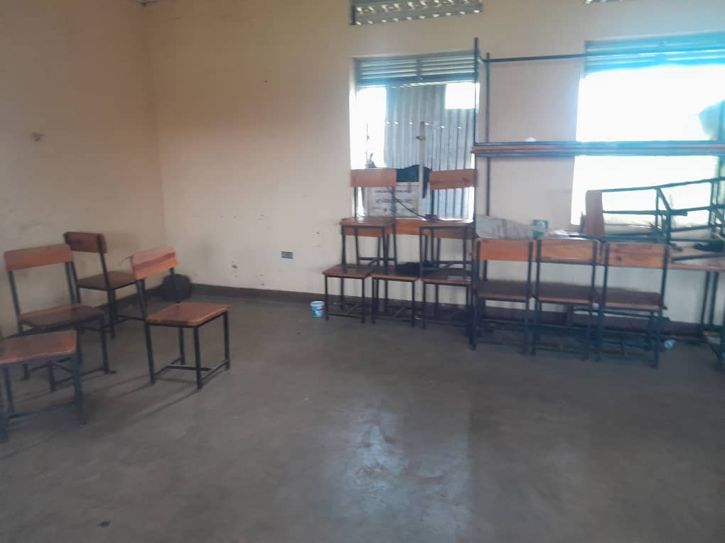
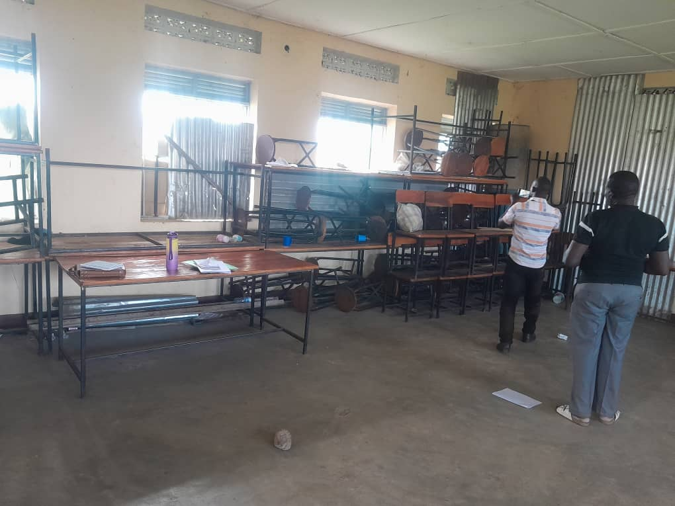
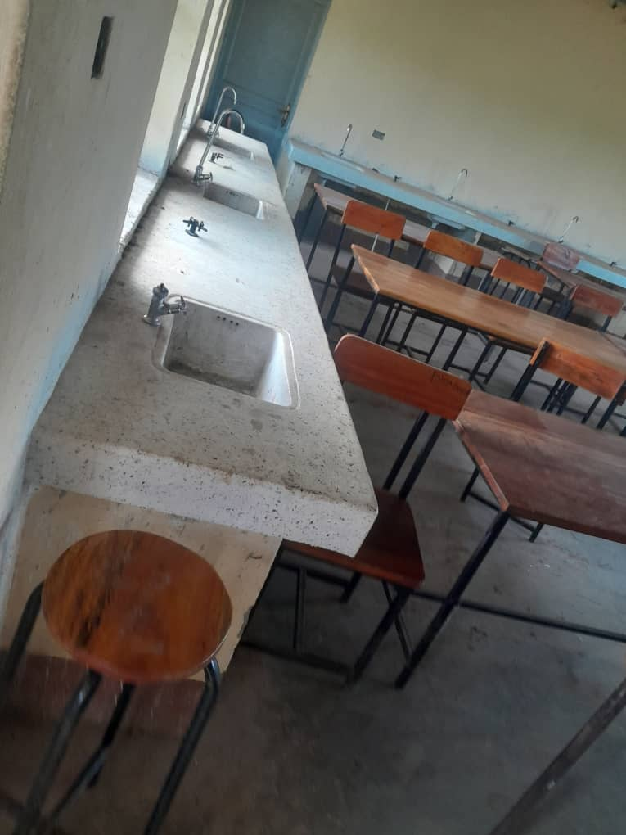
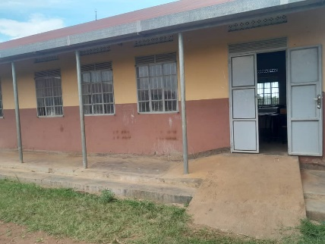
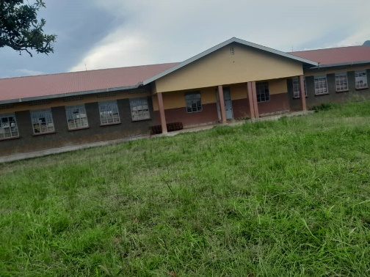
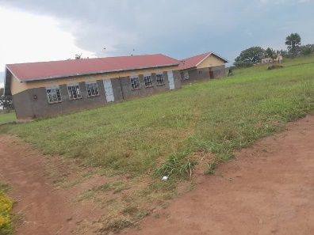
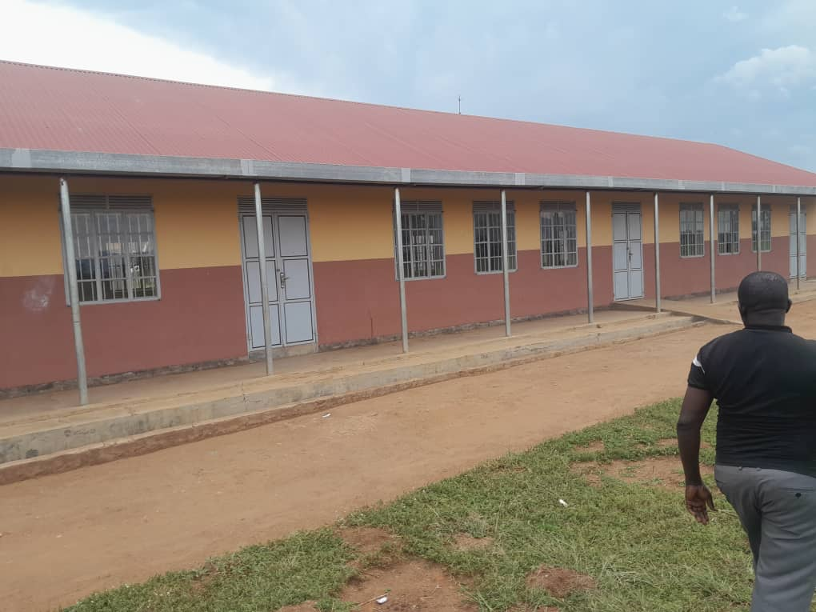
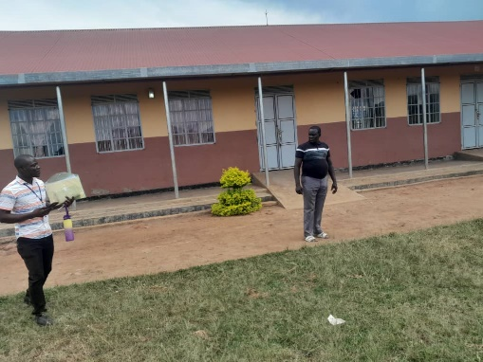
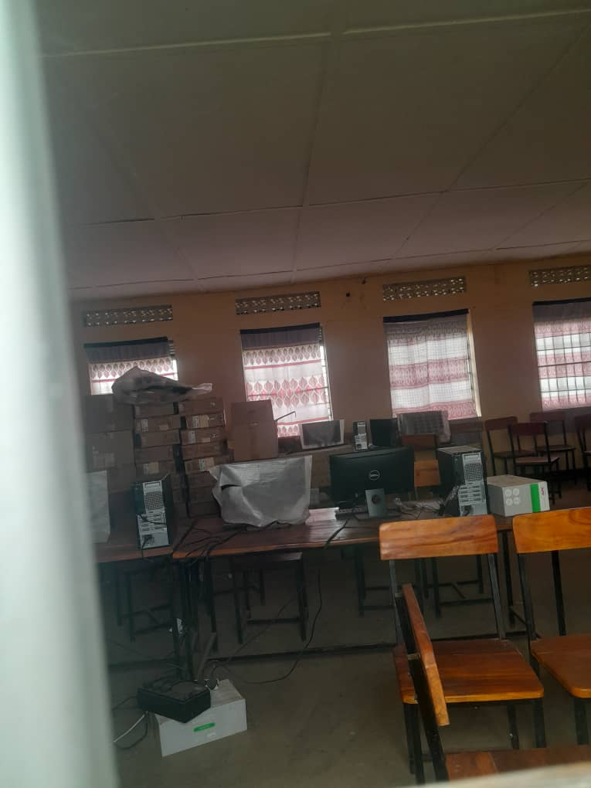
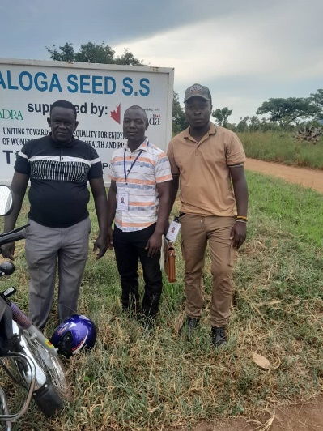
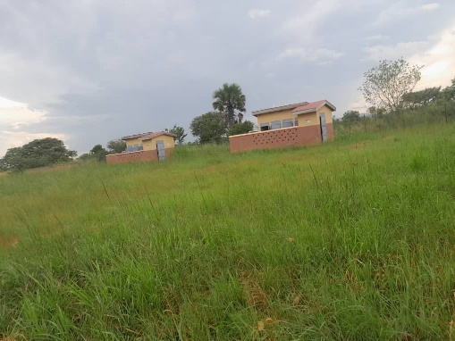
IMAGES FROM THE SCHOOL
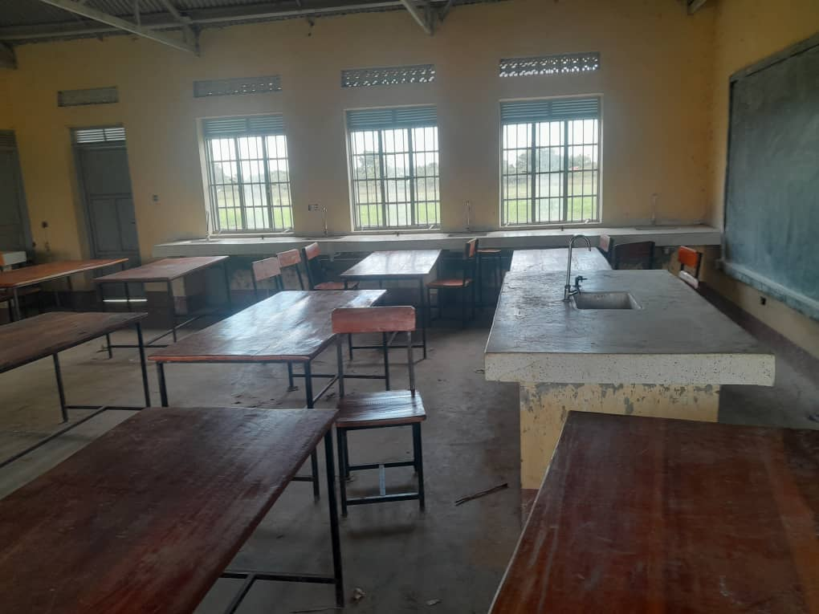
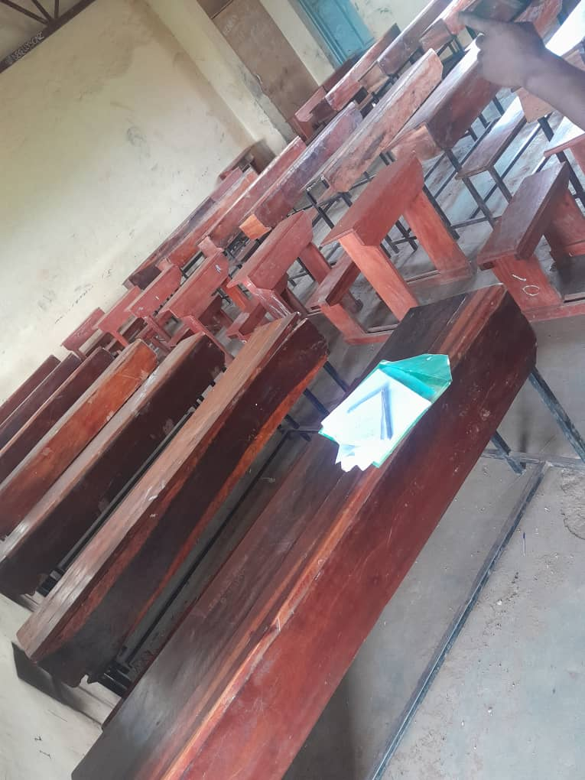
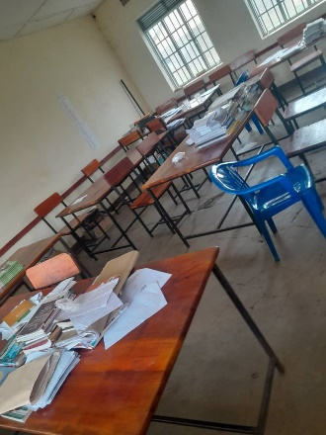

PADIBLE SEED SECONDARY SCHOOL – PADIBLE TOWN COUNCIL
DEO:
- The DEO said that the UGIFT Assets provided for the school were still at the district stores since the school is still under construction.
- The assets found at the district stores that belonged to the PADIBLE Seed Secondary school include;
- 20 Desktop Computer
- 1 Serve processor
- 1 Network switch 2upat
- 1 Multi-purpose Printer
- 1 Projector
- 1 Air Conditioner
- 1 Camera set
- 20 UPS
- 1 Save
- We proceeded to the school promises and found the following buildings;
- 3 Class room blocks, each block with 2 class rooms
- 1 Building block with staff offices and a Staff room
- 1 Main hall (Multi-Purpose)
- 1 Science laboratory building
- 1 Computer Laboratory building
- 5 Toilets (3 staff toilets each with 2 standers and 2 school toilets for students with 4 standers each)
- 1 Pitch still under construction
- Fence with wire mesh
- 2 Water tanks but not yet installed
- 1 Water tank Stand (Metallic)
- NB: Furniture is not yet at school

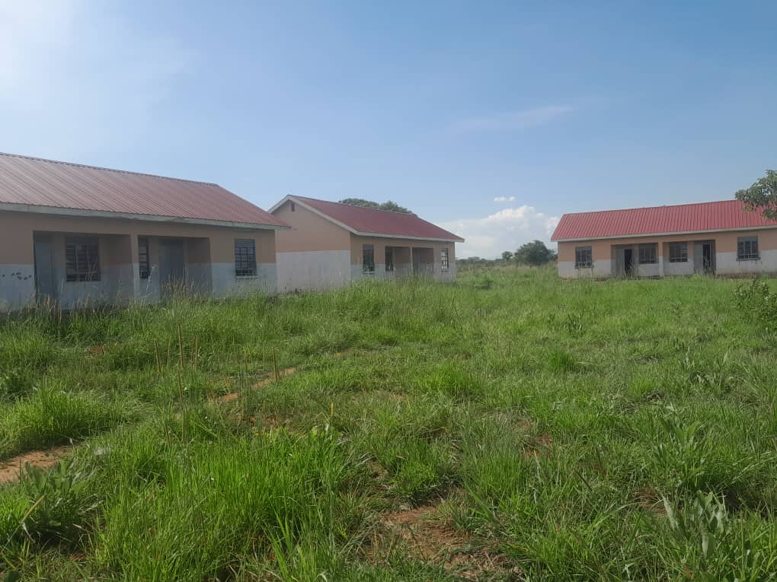
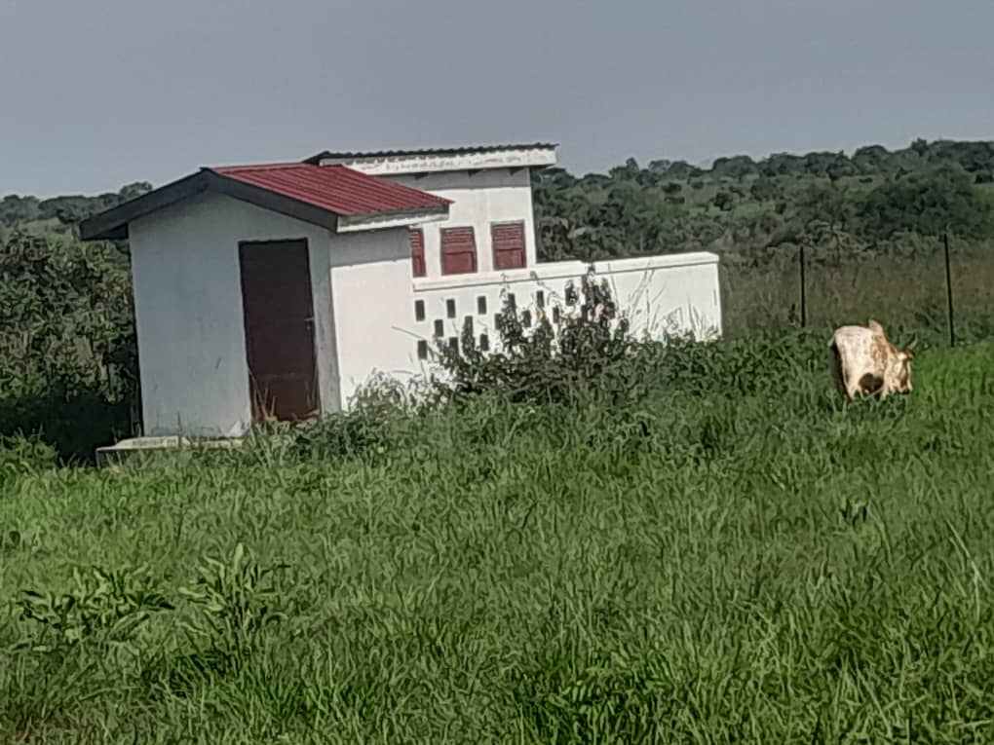
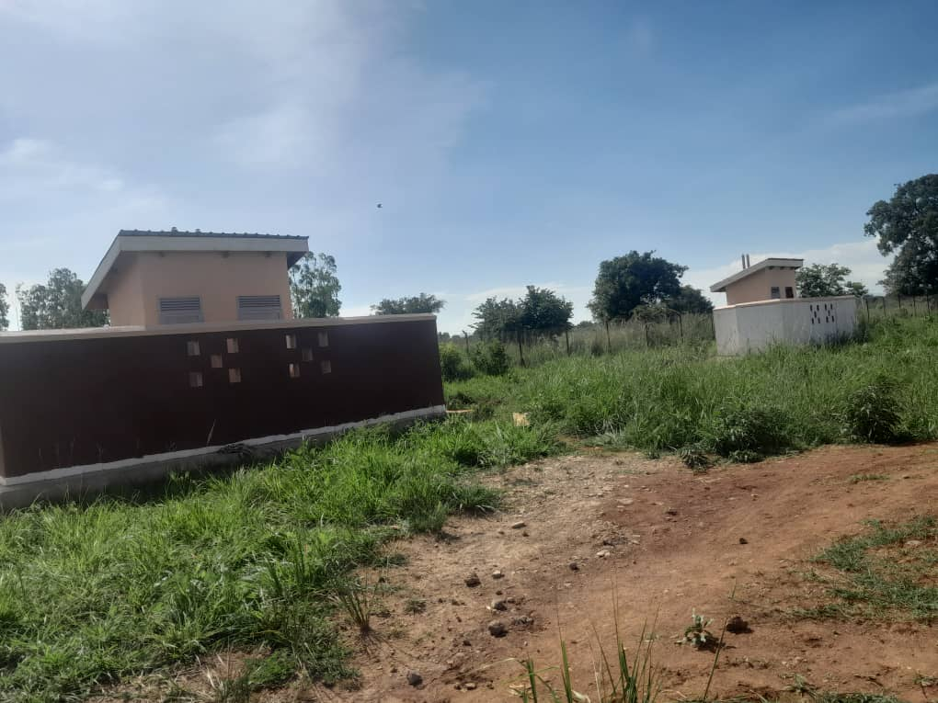
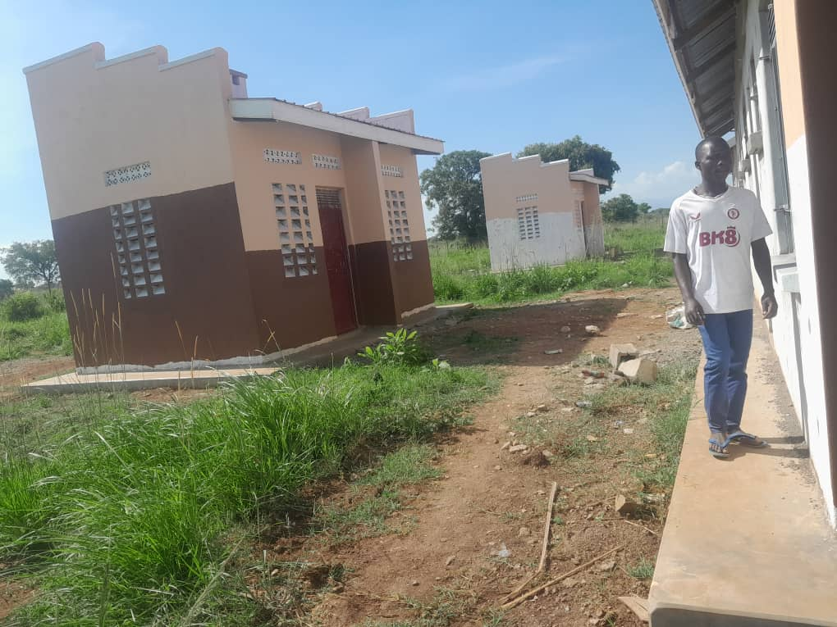
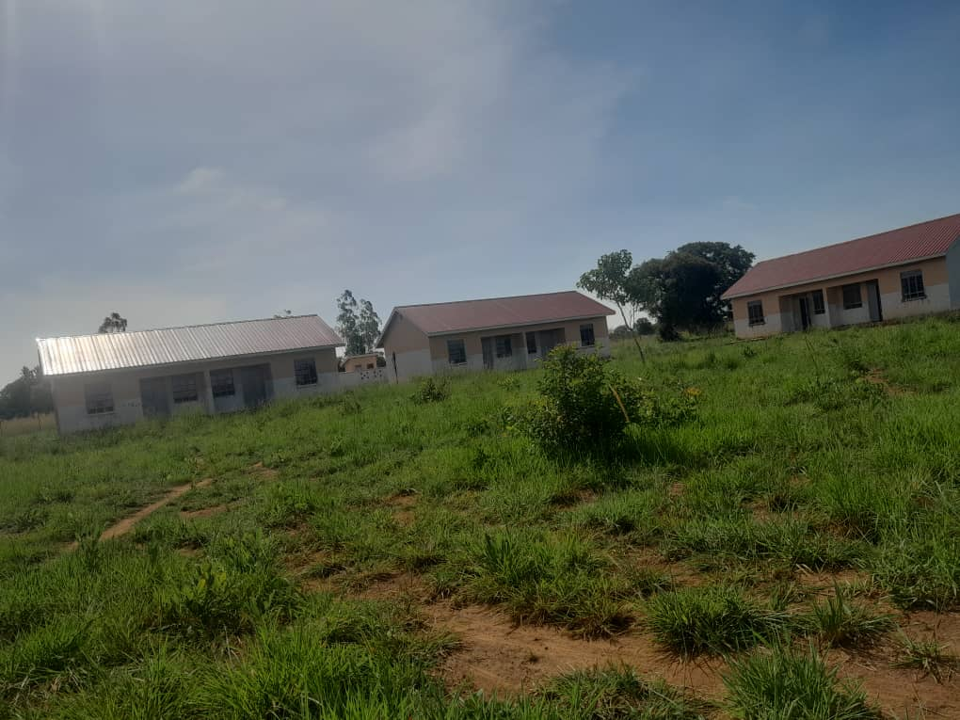
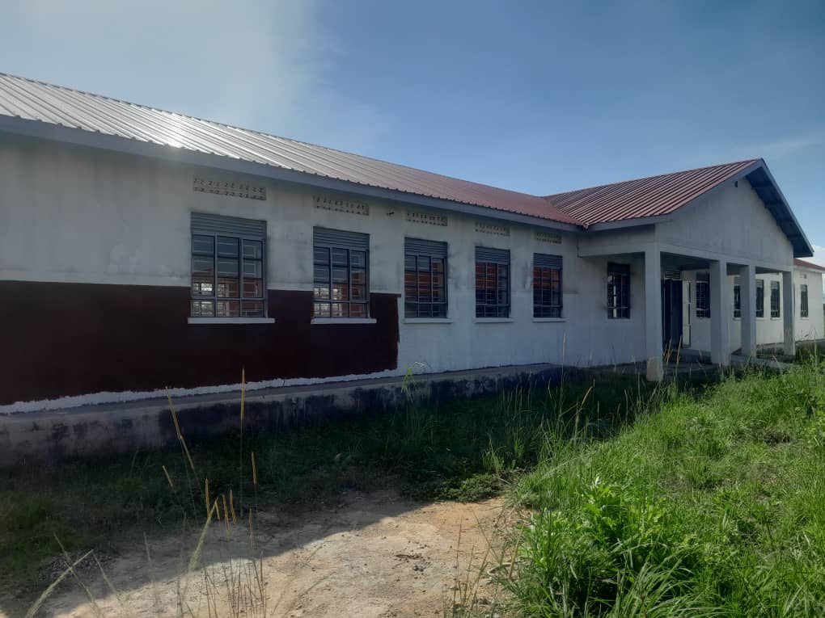
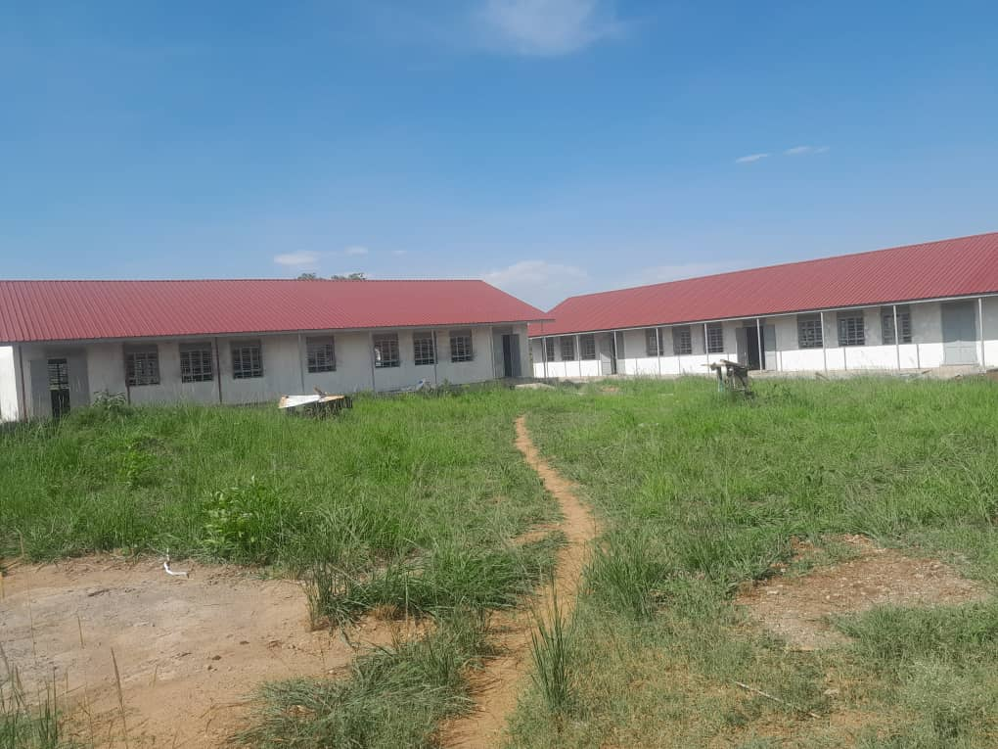
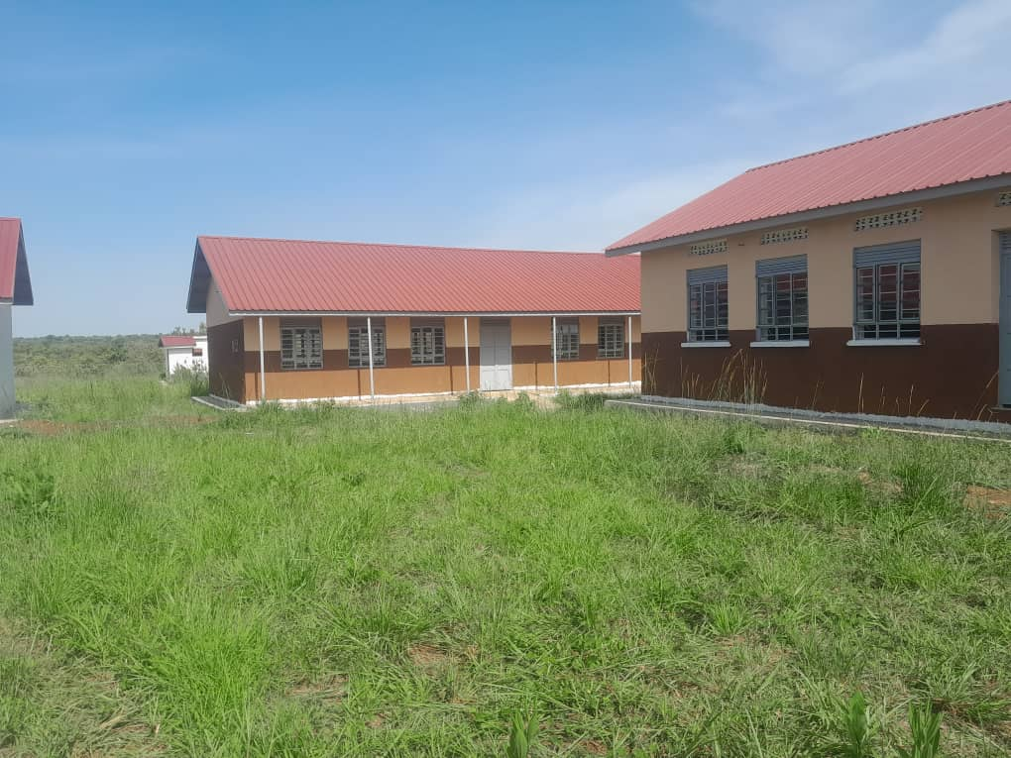
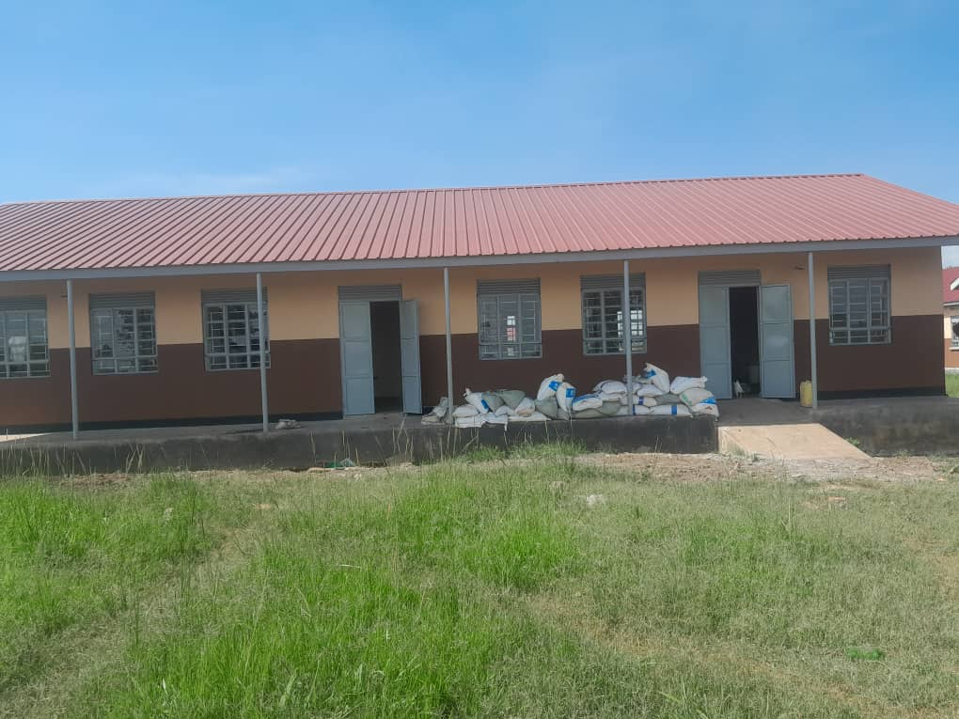
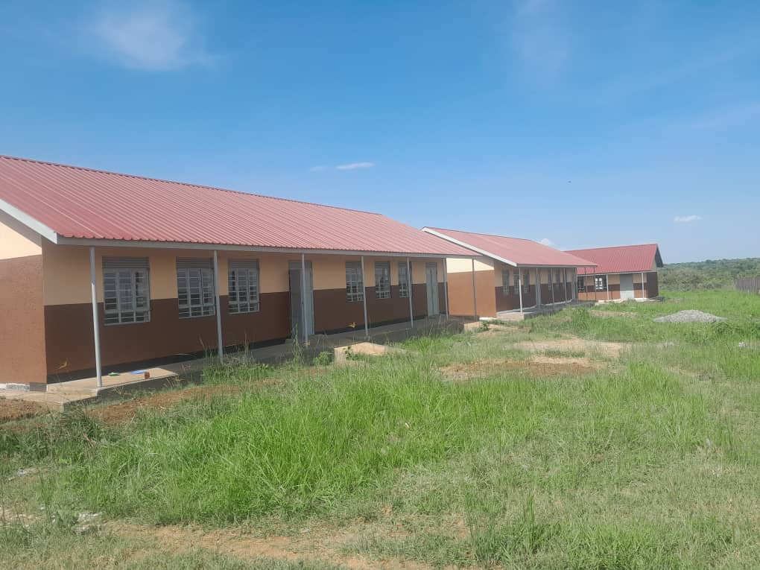
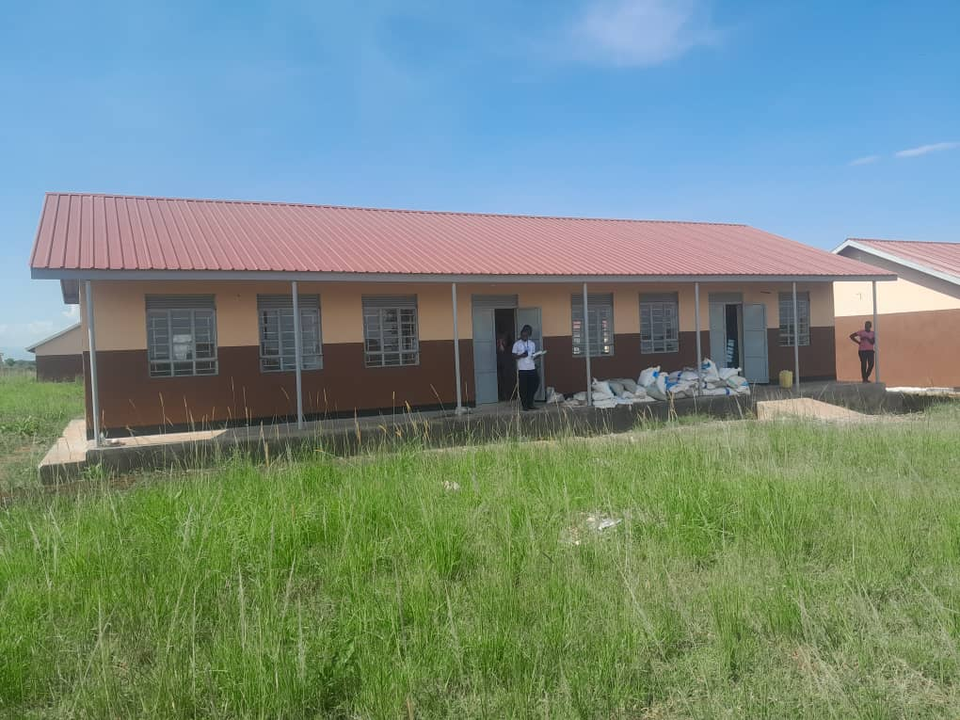
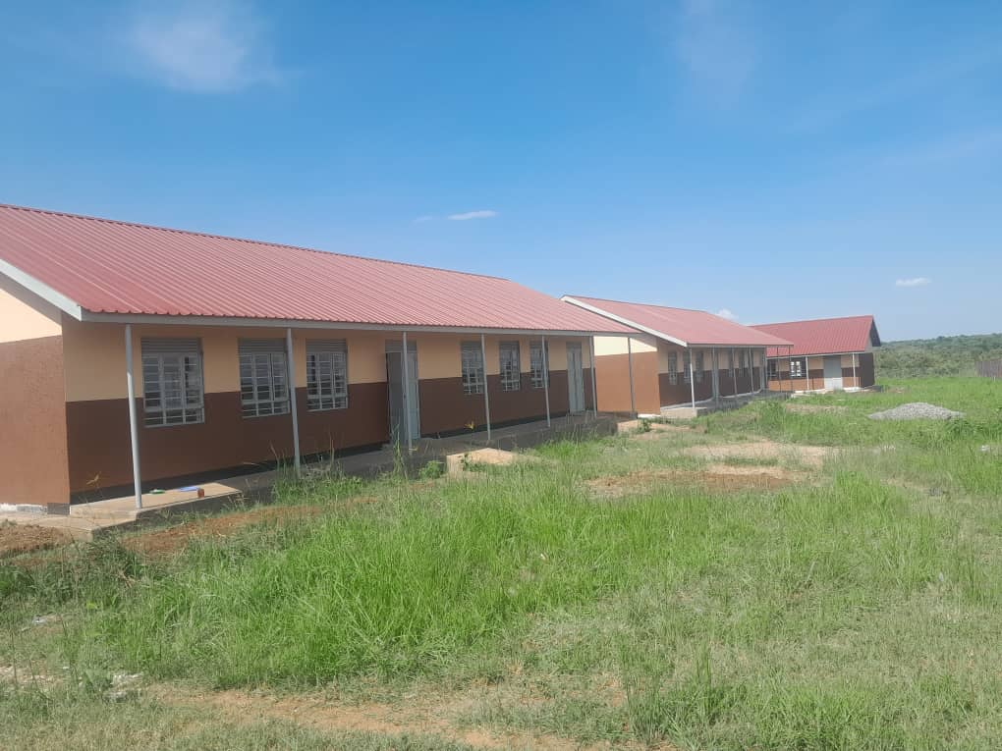
IMAGES FROM SCHOOL

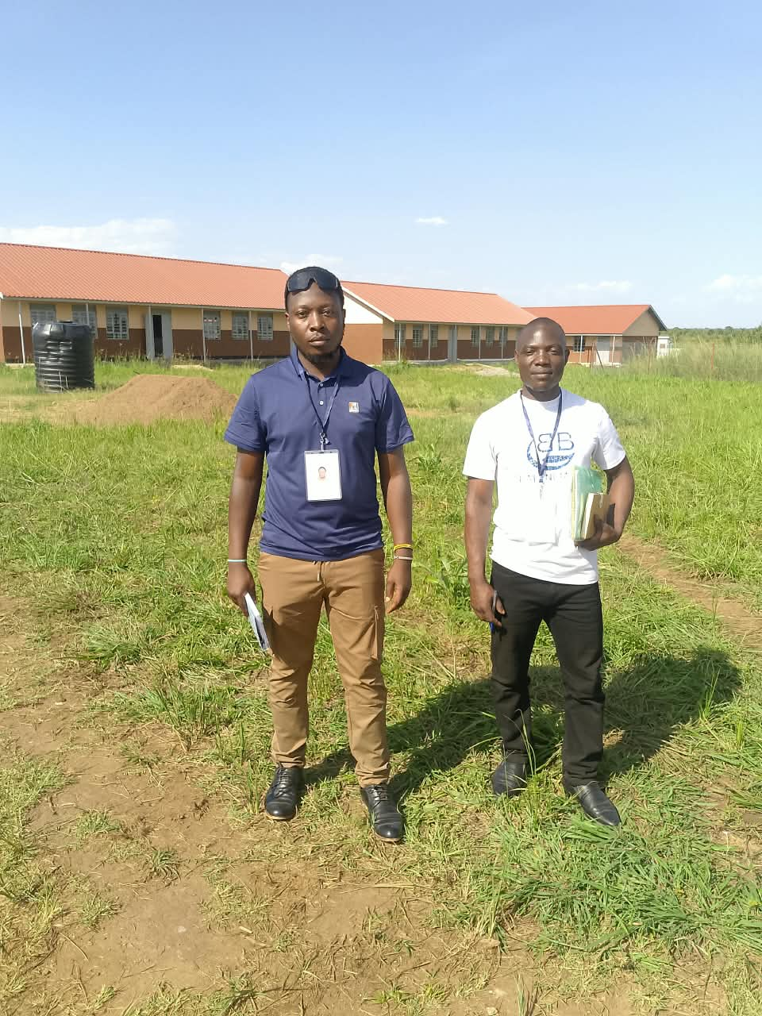
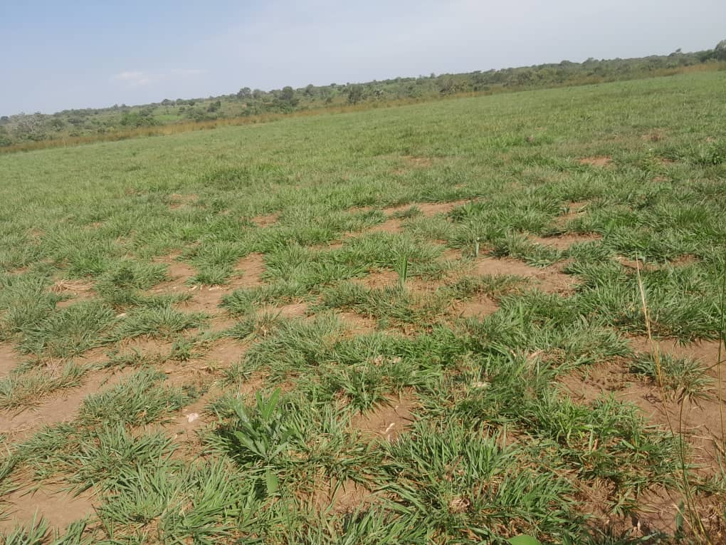
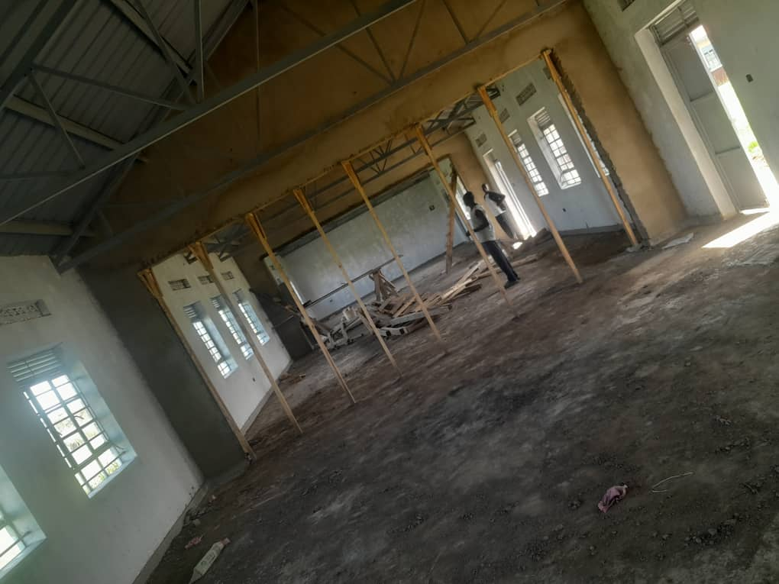
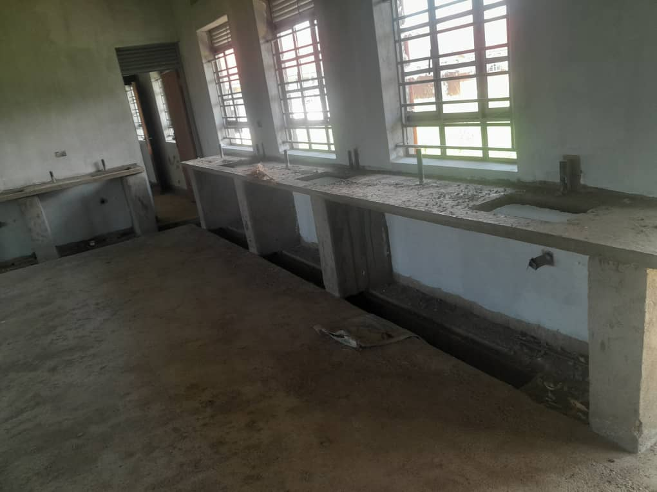
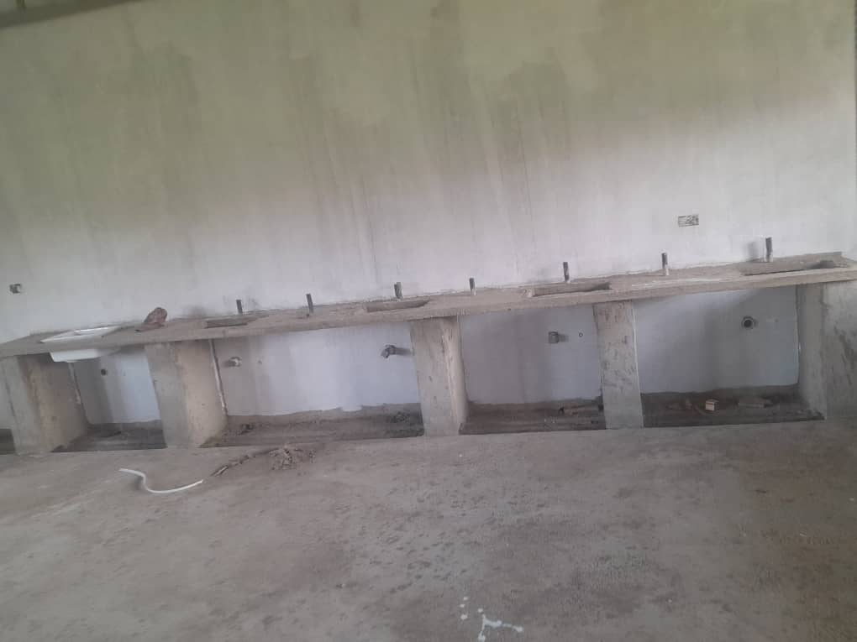
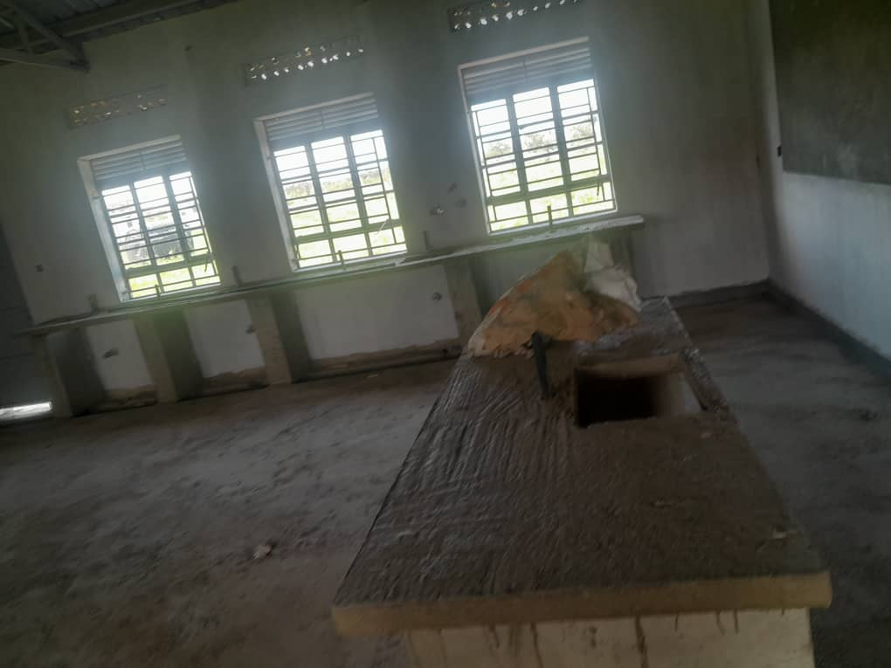

Report By:
Akwankwatsa Edwin
Tel: 0702527069
Email: piaedie@gmail.com

